Shaik Sharifa Jahan

AP22110011103

1. (a) Write a program in assembly language to print the numbers from 0 to 9.

org 100h

mov cx,10

mov dx,48

print_num:

mov ah,02he

int 21h

inc dx

loop print_num

mov ah,4Ch

int 21h

end

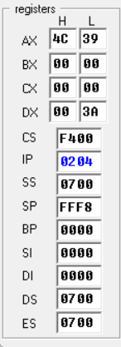

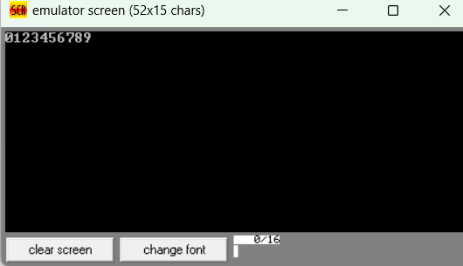

(b) Write an assembly language program to print the characters from A to Z in reverse order.

org 100h

mov cx,26

mov dx,90

print_rev_letter:

mov ah,02h

int 21h

dec dx

loop print_rev_letter

mov ah,4Ch

int 21h

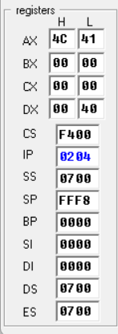

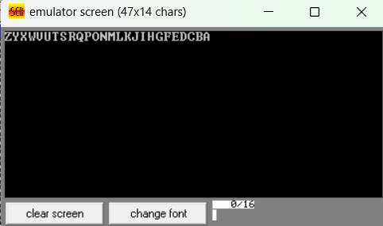

1. (a) Write a program in assembly language to print the numbers from 0 to 9 in reverse order.

org 100h

mov cx,10

mov dx,57

print_rev_digit:

mov ah,02h

int 21h

dec dx

loop print_rev_digit

mov ah,4Ch

int 21h

end

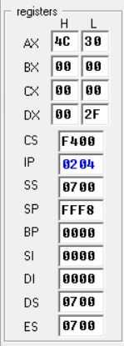

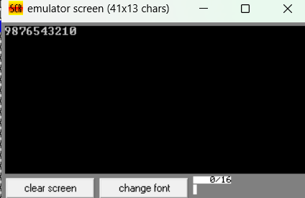

(b) Write an assembly language program to print the characters from A to Z.

org 100h

mov cx,26

mov dx,65

print_letter:

mov ah,02h

int 21h

inc dx

loop print_letter

mov ah,4Ch

int 21h

end

